**EMTH1019 Linear Algebra and Statistics for Engineers**

# Week 3 Solutions

1. (a) For *n* = 64, $σ_{\overline{x}}$ = 5*.*6*/*8 = 0*.*7, whereas for *n* = 196, $σ_{\overline{x}}$ = 5*.*6*/*14 = 0*.*4. Therefore, the variance of the sample is reduced from 0.49 to 0.16 when the sample size is increased from 64 to 196.
   1. For *n* = 784, $σ_{\overline{x}}$ = 5*.*6*/*28 = 0*.*2, whereas for *n* = 49, $σ_{\overline{x}}$ = 5*.*6*/*7 = 0*.*8. Therefore, the variance of the sample is increased from 0.04 to 0.64 when the sample size is decreased from 784 to 49.
2. (a)

* 1. , Therfore

*P*(172*.*45 *< X <*¯ 175*.*85) = *P*(−1*.*49 *< Z <* 0*.*98) = 0*.*8365 − 0*.*0681 = 0*.*7684. Therefore, the number of sample means between 172.5 and 175.8 inclusive is (200)(0*.*7684) = 154.

(c) *z* = (171*.*95 − 174*.*5)*/*1*.*38 = −1*.*85. So,

*P*(*X <*171*.*95) = *P*(*Z <* −1*.*85) = 0*.*0322.

Therefore, about (200)(0*.*0322) = 6 sample means fall below 172.0 cm.

1. (a) *µ* = $Σ$*xf*(*x*) = 4(0*.*2) + 5(0*.*4) + 6(0*.*3) + 7(0*.*1) = 5*.*3 and *σ*2 = (*x* − *µ*)2*f*(*x*) = (4−5*.*3)2(0*.*2)+(5−5*.*3)2(0*.*4)+(6−5*.*3)2(0*.*3)+(7−5*.*3)2(0*.*1) =0*.*81
   1. With *n* = 36, = *µ* = 5*.*3 and = *σ*2*/n* = 0*.*81*/*36 = 0*.*0225
   2. *n* = 36, $μ_{\overline{x}}$ = 5*.*3, $σ_{\overline{x}}$ = 0*.*9*/*6 = 0*.*15 and *z* = (5*.*5 − 5*.*3)*/*0*.*15 = 1*.*33. So, *P*(*X <*¯ 5*.*5) = *P*(*Z <* 1*.*33) = 0*.*9082.
2. With *n* = 36, $μ_{\overline{x}}$ ¯= 40, $σ_{\overline{x}}$ = 2*/*6 = 1*/*3 and *z* = (40*.*5 − 40)*/*(1*/*3) = 1*.*5, So,



1. n=100 so $\overline{X }$ will have an approximately normal distribution. *P*(|*X*¯ −*µ*| ≤ 1) =
2. We want *P*(|− *µ*| ≤ 1) = *P*(−1 ≤ ( $\overline{X}$ − *µ*) ≤ 1) = 0*.*95

We know that since *σ* = 10,

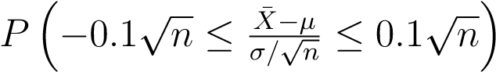

is approximately equal to *P*(−0*.*1 $\sqrt{n}$ ≤ *Z* ≤ 0*.*1 $\sqrt{n}$).

From tables, we know that *P*(−1*.*96 ≤ *Z* ≤ 1*.*96) = 0*.*95 and it must follow that $0.1\sqrt{n}=1.96, n={\left(\frac{1.96}{0.1}\right)}^{2}=384.16=385=n$

Thus 385 test welds should be used for the sample mean to have a 95% chance of being within 1 psi of the population mean.

1. The average strength *X*¯ has approximately a normal distribution with mean *µ* = 14 and standard deviation $\frac{σ}{\sqrt{n}}=\frac{2}{100}=0.2$

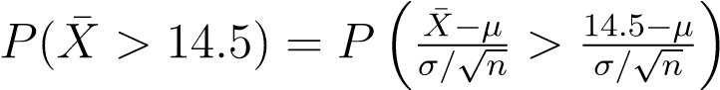 is approximately equal to



1. The probability that we choose to compute is given by *P*(|*X*¯ − 5| ≥ 0*.*027). In other words, if the mean *µ* is 5, what is the chance that *X*¯ will deviate by as much as 0.027 millimetre?



Here we are simply standardising *X*¯ according to the Central Limit Theorem. If

the conjecture *µ* = 5 is true, should follow *N*(0*,*1). Thus,

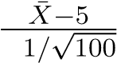0*.*



Therefore, we would experience by chance that an ¯*x* would be 0.027 millimetre from the mean in only 7 in 1000 experiments. As a result, this experiment with *x*¯ = 5*.*027 does not give supporting evidence to the conjecture that *µ* = 5*.*0. In fact, it strongly refutes the conjecture!

1. (a) 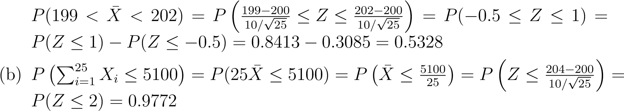

(c) Independent random sample

1. (a) $\overline{x}$ = 2*.*6. The *z*-value leaving an area of 0.025 to the right, and therefore, an area of 0.975 to the left, is *z*0*.*025 = 1*.*96 (from tables). Hence, the 95% confidence interval is

2*.*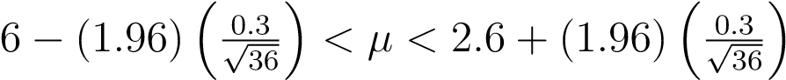, i.e. 2*.*50 *< µ <* 2*.*70

(b) The *z*-value leaving an area of 0.005 to the right, and therefore, an area of 0.995 to the left, is *z*0*.*005 = 2*.*575 (from tables). Hence, the 99% confidence interval is: $2.6-(2.575\left(\frac{0.3}{\sqrt{36}})<μ<2.6+2.575\left(\frac{0.3}{\sqrt{36}})\right)\right),$ 
 that is 2.47< $μ<2.73$

As can be seen a longer interval is required to estimate *µ* with a higher degree of confidence

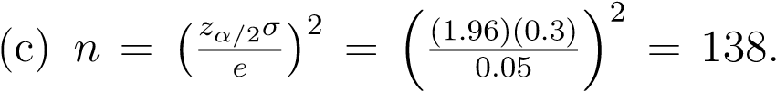3 Therefore, we can be 95% confident

that a random sample of size 139 will provide an estimate ¯*x* differing from *µ* by an amount less than 0.05.

1. *α* = 0*.*02. The *z*-value leaving an area of 0.01 to the right, and therefore, an area of 0.99 to the left, is *z*0*.*01 = 2*.*33 (from tables). Hence, the 99% confidence interval is

, i.e. 17*.*98 *< µ <* 18*.*82

Thus we are 98% confident (similarly formed intervals will contain *µ* about 98% of the time in repeated sampling) that the true mean lies between 17.98 and

18.82.

Take a careful look at the interpretation of confidence interval statements. The interval is *random*; the parameter is fixed. Before sampling, there is a probability of (1−*α*) that the interval will include the true parameter value. After sampling, the resulting realisation of the confidence interval either includes the parameter value or fails to include it, but we are quite confident that it will include the parameter value if (1 − *α*) is large.